

Functional Specification

Document -MOHRE

RELEASE 1.0

Copyright © 2018 Beyontec Solutions

All rights reserved. This product and related documentation are protected by copyright and distributed under licensing restricting their use, copying, distribution, and recompilation. No part of this documentation may be reproduced in any form or by any means without prior written authorization of Beyontec Solutions.

This publication and features described herein are subject to change without notice.

Restricted Rights

Beyontec

Post Box 32252  
1207 Indigo Icon Tower,  
Jumeirah Lake Towers, Dubai, UAE  
Phone: +97145148451

Contents

1. Introduction 3

1.1 Objective: 3

1.2 Scope: 3

2. Requirement: 4

2.1 Landing Page: 4

2.2 Login Page 4

2.3 User Master: 5

2.3 User Name and Password Valedictory: 6

3. Work Flow: 7

3.1 Flow Chart: Master Policy 7

3.2 Step by step Process: Master Policy 8

3.3 Menu: 9

4. Master Policy Creation 10

4.1 To Create a Master 10

4.2 Master Search Screen: 10

4.3. Master Endorsement Cancellation and Renewal: 11

4.4 Field Details: 14

5.Claims 15

5.1 Claims Flow Chart 15

5.2 Menu 16

5.3 Claims Search Screen: 16

5.4 Claims Header: 17

Technical details to fetch this information: 17

5.5 Claims Registration: 17

Technical details to fetch this information: 18

5.6 Document: 18

5.7 Notes: 19

5.8 Payment Estimation Types 20

5.9 Manual Estimation Creation Details (Mostly the estimation will create automatically): 20

5.10 Manual Recovery Estimation Creation details: 21

5.11 Work Basket: 22

5.12. Estimation Review & Approve: 22

5.13 Claims Open, Close & Reopen 24

**1**

**1. Introduction**

## 1.1 Objective:

This is the Functional Requirement Specification for Worker Visa Insurance – MOHRE. Application to be part of Beyontec Suite. Beyontec suite performs all of the process and transaction necessary to write and administrate insurance business.

The functional requirement specification for MOHRE will provide the general as well as specific requirements to be used in design, testing and validation of the application.

## 1.2 Scope:

The FRS will addresses the functions of Worker Visa Insurance - MOHRE, Application must be able to successfully perform primary business functionality. This document also addresses insurance regulatory and Beyontec Suite requirements for Worker Visa Insurance - MOHRE. The focus is on what the Worker Visa Insurance - MOHRE application must do details on how the application will be developed and how it will operate will be defined in the Software Design Specification.

**2. Requirement:**

## 2.1 Landing Page:

Once the application is launched through URL, Application to land on the landing page. Landing page to support co-branding i.e., Logo of insurance company and Beyontec to be available. Application will have Employee Portal to Login as Employee (Insurance Company).

## 2.2 Login Page

Login page to capture Username and password. Application to validate the entered username and password and allow user to login into the system. If user forgot password, user will approach IT admin to regenerate new password. This new password will come as email to user and user will use this password to login. (New password generation by IT Admin will happen through Beyontec Suite Master).

First Time Login – Mandate user to change the password and the application navigates to the password reset screen if the user is logged into the system for the first time. In Beyontec suite, we track “First login” and needs to be updated after successful login.

**Technical Input:**

The password reset page will have the below listed details

|  |  |  |  |  |
| --- | --- | --- | --- | --- |
| **#** | **Field** | **Data Type** | **Mandatory** | **Validation/Remarks** |
| 1 | Username |  | Y | To be defaulted with logged in user name |
| 2 | Old Password | Free Text | Y |  |
| 3 | New Password | Free Text | Y |  |
| 4 | Confirm New Password |  | Y |  |
| 5 | Favorite Question | Free Text | Y |  |
| 6 | Answer | Free Text | Y |  |
| 7 | Enable Virtual Keyboard | Check Box |  | On selecting the check box application to enable virtual key board |
| 8 | Save | Button |  | 1. Application to validate the entered old username and username, if the details match application to application to logout and land in login screen.  2. If the entered old password is wrong application to raise ‘Invalid Old password’.  If the new password and confirm new password did not match application to raise ‘New password mismatch with Confirm new password’ and vice versa |
| 9 | Reset | Button |  | Application to clear all the entered details. |

Application to display password profile rules after the above details. This information will act as reference to user while creating new password.

If the user wants to reset the password then the user can reset his password from the home screen. Password Reset – This needs to be available in Home page.

Click on the link of the **User Name - > Password Reset** .Then the application will leads to the password reset screen. The password reset screen have the mentioned above fields.

## 2.3 User Master:

Below are description of user Master function and it is available in Beyontec suite. We need to use below functions to validate in the login and transactions.

**User Group:**

In the user group will define with Applicable Products, Applicable menu and Endorsement Menus.

**User Authorization:**

User authorization will be defined at group level and the user will be mapped with the user Group.

**User Creation:**

In the User Master we will define the user login credentials, role of the user, Module, division and department and the user belongs to the respective user group. And the User level privileges can be defined in the user Creation master.

## 2.3 User Name and Password Validity:

Users will be created form user creation master and will be provided with a username and password. Existing user will enter the username and password application to validate the entered details. If user enters the correct password application to login the user and land in home page. In case of invalid username and password application to raise ‘Invalid Password’ message along with how many times username and password can be entered and validated. Refer user password profile master for other validations for Password.

This needs to cover under “Password” reset.

**3. Work Flow:**

**FSD Covers:**

* Master Policy Creation
* Claims Registration

## 3.1 Flow Chart: Master Policy

The Work flow explained with step by step procedure and also with flow chart.

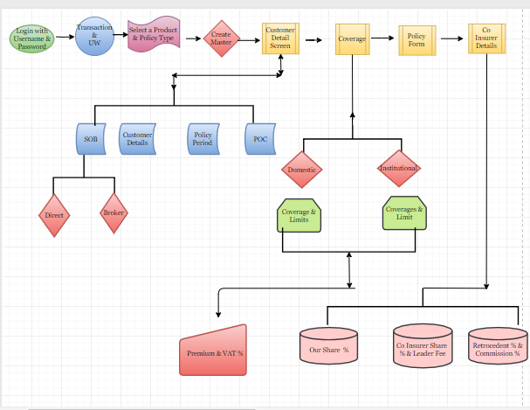

## 3.2 Step by step Process: Master Policy

* Login with valid user name and password
* Select the Master Menu
* Select a Product
* Select Policy Type
* Create Master Policy.
* Customer detail section (Division & Department, SOB, Customer details, General information & POC)
* Coverage (Employee category – Domestic/Institutional; Selection of covers, Coverage Limit, Premium & VAT)
* Policy Forms – For selection
* Co Insurer details & Save the Master Details
* Go for Approval
* Task Referred to Approver work Basket
* Approve the Record

## 

## 3.3 Menu:

Application to load the menu based on logged in user group.

Menu will list with various modules with icon.

* Master
* Work Basket
* Dash Board
* Reconciliation
* Claims
* Co Insurer & Re Insurer Processing Screen.
* Accounting Processing screen

**4. Master Policy Creation**

## 4.1 To Create a Master

Select the product Name from the drop down and select the policy type as Master and click on create a Master Button.

The Product listed in the home screen has configured in the product master and the product attached with the user group.

**Product Name - > Policy Type - > Create Master**

|  |  |  |  |  |
| --- | --- | --- | --- | --- |
| **Field Name** | **Field Type** | **Mandatory** | **Validation Message** | **Remarks** |
| Select a Product | Drop Down | Yes | Product is required | Without selecting the Product Name try to create master, application need to raise an alert message and **say “Product is required”** |
| Select Policy Type | Drop Down | Yes | Policy Type is required | Without selecting the Policy Type try to create master, application need to raise an alert message and **say “Policy Type is required”**  Without selecting the Product, application should not load the Policy Type. |
| Create Master | Button | Yes |  | Click on the button to get into the application screen. |

## 4.2 Master Search Screen:

The Below fields are the search parameter to query the existing record in the system

|  |  |  |
| --- | --- | --- |
| **Field Name** | **Field Type** | **Remarks** |
| Master Policy No | User Enterable | The Respective policy No should exist in the current system. |
| Customer Name | User Enterable | The Respective Customer Name should exist in the system. |
| Product Type | Drop Down | Need to select from the drop down. |

**Listing screen:**

Information to be listed.

# Policy No

# Policy From date

# Policy to date

# Policy Status - Quote/Policy

During search if the relevant record is not found in the system then the Message need to raise as record is not found.

The Screen will have an option to view the endorsements records of the Master Policy. User should be in a position to view Policy and each endorsement and related changes during each endorsement.

**Technical input on Filtering Master policy to Display:**

## 4.3. Master Endorsement Cancellation and Renewal:

To pass any endorsement or cancellation or renewal Click on the Action button to find the

Options like Endorsements, Cancellation and Renewal.

Action - > Endorsement

Cancellation

Renewal

**Endorsement:**

**Master Policy - > Endorsements - > Endorsements Type - > Risk Change endorsement - >**

**Endorsement Effective from date**

|  |  |  |  |  |
| --- | --- | --- | --- | --- |
| **Field Name** | **Field Type** | **Mandatory** | **Validation Message** | **Remarks** |
| Endorsement -Risk Endorsement | Radio Button | Yes |  | Action ->Endorsements -> Risk Change Endorsements.  Default the endorsement option with Risk change endorsements.  To Process the endorsements endorsement type is mandatory. |
| Endorsement effective From Date | Data entry and Calendar | Yes |  | Default the effective from date as current system date.  Effective from date can be as future date.  Effective from date should not be greater than the policy To date. |
| Endorsement effective To date | Data entry and Calendar | Yes |  | System need to default the effective To date as Policy To date and the To date should not be in edit mode. |
| Reason | Drop down | Yes | Reason is required | Default the Reason with Customer Request. |

Any endorsement in system will happen in the following flow. Once Endorsement process started, system needs to generate endorsement quote (Using Latest impression of Master Policy). User will make changes on the endorsement quote and confirm. Updated endorsement quote will be moved to Policy.

Through the risk change endorsements the user can alter the customer details, Coverage, Policy Forms & Co insurer details. Once the user save the endorsement quote it will go for approval and after the endorsement quote approval the amendment changes will get impact on the further more issuance of certificate.

**Status:**

**Endorsement Requested – During Endorsement (until endorsements approved)**

**Policy Issued – After Endorsement appoved (Endorsement Policy Approval)**

**Cancellation:**

To Cancel the current master Policy, **Action - > Cancel -> Cancellation Effective From date** and cancellation effective to date should be defaulted with the Policy To Date. After the cancellation the policy status should be maintained as cancel.

|  |  |  |  |  |
| --- | --- | --- | --- | --- |
| **Field Name** | **Field Type** | **Mandatory** | **Validation Message** | **Remarks** |
| Endorsement –Cancellation Endorsements | Radio Button | Yes |  | Action ->Endorsements -> Cancel Endorsements.  Default the endorsement option with Risk change endorsements.  To Process the endorsements selecting the endorsement type is mandatory. |
| Endorsement effective From Date | Data entry and Calendar | Yes |  | Default the effective from date as current system date.  Effective from date can be as future date.  Effective from date should not be greater than the policy To date. |
| Endorsement effective To date | Data entry and Calendar | Yes |  | System need to default the effective To date as Policy To date and the To date should not be in edit mode. |
| Reason | Drop down | Yes | Reason is required | Default the Reason with Customer Request. |

**Status: Cancel**

**Renewal:**

Renewal will start when the policy period is about to expire then user can renew the current master policy through the renewal option. **Action -> Renewal.**

During Renewal user can alter the policy details**.** And the Policy From date and To date should get defaulted with the next set of period. User can change the Policy From date based on the From date To date need to set automatically. And the To date should not allow to change.

**Example:**

**Status:**

**During quote stage - Quote**

**After quote approval – Active**

## 4.4 Field Details:

Field Name and the validation for Master screen are mentioned in the below table. This list is applicable to New Master Policy, Endorsement and Renewal. Below attached excel contains information & fields across all block of Master Policy.



**1**

**5.Claims**

## 5.1 Claims Flow Chart

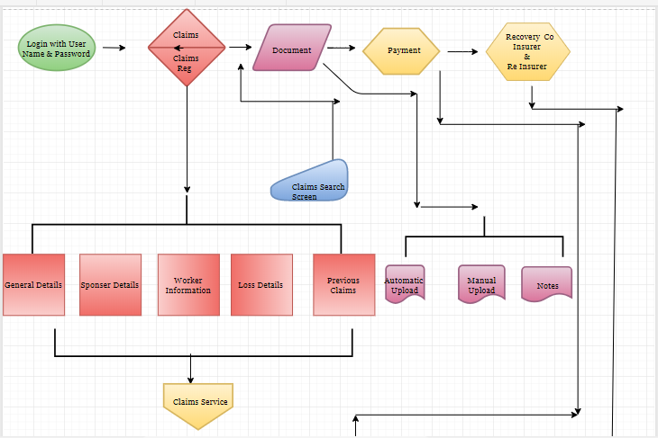

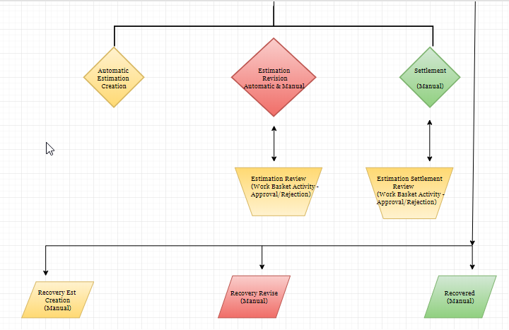

## 5.2 Menu

To Process the claims**, User Name -> Password -> Home screen - > Claims -> Claims Registration.**

**Menu:**

* Claims
* Claims Registration

In the Claims Module there is no option is required to create any claims manually.

## 5.3 Claims Search Screen:

Query the Claim No through any one of the parameter which mentioned below,

|  |  |  |
| --- | --- | --- |
| **Field Name** | **Field Type** | **Remarks** |
| Claim No | User Enterable | Unique No |
| Certificate No | User Enterable | Unique No |
| Emirates ID | User Enterable | Unique No |
| Worker Name | User Enterable |  |
| Sponsor/Institution Name | User Enterable |  |
| Worker Type | Drop Down |  |
| Loss Date | User Enterable |  |
| Status | Drop Down |  |
| Division | Drop Down |  |
| Department | Drop Down |  |
| Batch No | Drop Down |  |

**Search actions:**

**Claim No -> Action -> Edit**

**Listing screen:**

* Claim No
* Policy No
* Loss date
* Created date
* Insured name
* Batch ID
* Sponsor Name
* Status

## 5.4 Claims Header:

The Claims Header will follow up in all the Claims Screen. The Claims Header carries the following information,

* Master Policy No
* Certificate No
* Product Name
* Worker Name
* Certificate From Date and To Date
* Institution/Sponsor Information
* Claims Status

## Technical details to fetch this information:

This information will be fetched from Certificate.

## 5.5 Claims Registration:

Claims Registration page will have the mentioned below sections, those details will get through the Claims service, user can edit the mentioned below data,

* **Sponsor Details**
* **Worker Information**
* **Loss details**
* **Previous Claims History**

## Technical details to fetch this information:

## 5.6 Document:

In the document screen the document will get uploaded through the claims service and Manual option is also available to upload the documents.

**Manual Document Upload Field details:**

|  |  |  |  |  |
| --- | --- | --- | --- | --- |
| **Field Name** | **Field Type** | **Data Type** | **Mandatory** | **Remarks** |
| New Document | Button | Characters | No |  |
| Party Type | Drop Down | Characters | Yes |  |
| Document Type | Drop Down | Characters | Yes |  |
| Description | User Enterable | Alphanumeric | No |  |
| Document upload | Upload | Drag/upload | Yes |  |
| Save | Button |  | Yes |  |
| Reset | Button |  | Yes |  |

## 5.7 Notes:

**Notes** – Notes option available in the document screen. The user can record the information in the notes.

|  |  |  |  |  |
| --- | --- | --- | --- | --- |
| **Fields** | **Field Type** | **Data Type** | **Mandatory** | **Remarks** |
| User Name | User Enterable | Characters | Yes | Default the user Name with login ID |
| Created Dates | Calendar and User Enterable | Numeric | Yes | Default with Current system Date |
| Due Date | Calendar and User Enterable | Numeric | Yes | If the Reminder is get checked then the Due date is mandatory. |
| Subject | User Enterable | Alphanumeric | Yes |  |
| Detail Description | User Enterable | Alphanumeric | No |  |
| Reminder | Check box |  | No |  |
| Save | Button |  | Yes | Save button will save the information entered in the notes screen. |
| Reset | Button |  | No | User can reset the details. |
| Save as Draft | Button |  | No | It will save as draft. The Record will be available under the draft header. |
| Create Response |  |  | No | The Notes created by one user the same can view by the other user and response to the notes |

## 5.8 Payment Estimation Actions

|  |  |
| --- | --- |
| **Activity** | **Estimation Creation Type** |
| Estimation Creation | Automatic Estimation creation(Manual/Automatic) |
| Estimation Revision | Manual/Automatic |
| Estimation Settlement | Manual Approval |
| Recovery Estimation Creation | Manual |
| Work basket Activity | Manual |

## 5.9 Manual Estimation Creation Details (Mostly the estimation will create automatically):

The estimation will create automatically through the claims service and revise estimation amount will also get updated through the claims service.

The revision can be done with service as well as manual.

**Action - > Revise - >Revise Estimation Amount -> Save**

**Reserve for - > Party type - > Cover - >Loss Type**

|  |  |  |  |  |
| --- | --- | --- | --- | --- |
| **Field Name** | **Filed Type** | **Data Type** | **Mandatory** | **Remarks** |
| Reserve For | Drop Down | Character | Yes | To Create an estimation Reserve for is required. |
| Coverage | List of Values | Character | Yes | To create an estimation Coverage is required. |
| Loss | List of Values | Character | Yes | To create an estimation loss type is required |
| Estimation Creation date | User Enterable and Calendar Selection | Numeric | Yes | Default the Value with current system date. |
| Estimation Amount | User Enterable | Numeric | Yes | To Create an estimation amount is required. |
| Save | Button |  | Yes | Estimation will create after getting save. |
| Revise Option | User enterable | Numeric | Yes | Revise option use to revise the estimation amount. |
| Settlement | Right click option | Character | Yes | Settlement option used for settling the amount.  Validation of Settlement amount:   1. It can’t be greater than Estimate amount. 2. Maximum of (Estimate – Settlement) |

## 5.10 Manual Recovery Estimation Creation details:

|  |  |  |  |  |
| --- | --- | --- | --- | --- |
| **Field Name** | **Filed Type** | **Data Type** | **Mandatory** | **Remarks** |
| Reserve For | Drop Down | Character | Yes | To Create an estimation Reserve for is required. |
| Coverage | List of Values | Character | Yes | To create an estimation Coverage is required. |
| Loss | List of Values | Character | Yes | To create an estimation loss type is required |
| Recovery Date | User Enterable and Calendar Selection | Numeric | Yes | Default the Value with current system date. |
| Recovery Amount | User Enterable | Numeric | Yes | To Create an estimation amount is required. |
| Save | Button |  | Yes | Estimation will create after getting save. |
| Revise Option | User enterable | Numeric | Yes | Revise option use to revise the estimation amount. |
| Recovered | Right click option | Character | Yes | Recovered option used to recover the amount. |

## 5.11 Work Basket:

|  |  |  |  |
| --- | --- | --- | --- |
| **Basket Name** | **Activity Purpose** | **Options Available** | **Remarks** |
| Payment Review | The estimation will be review by the Reviewer. | Action & Completed option will be available in the work basket level. |  |
| Payment Review Rejection | The estimation Review will be rejected by the Reviewer | Action & Completed option will be available in the work basket level. |  |
| Payment Approve | The Estimation will approve by the Approval after the Review Approval | Action & Completed option will be available in the work basket level. |  |
| Payment Approval Rejection | The Estimation Approval will be rejected by the Approver after the Review Approval | Action & Completed option will be available in the work basket level. | The Payment can either approve or reject. Those options will available in the payment screen @ Left hand side options will be available. |

**Work Basket Listing:**

**Ref No** = Claims NO/Policy No

**Insured Name** = Insured name

**Activity** = e.g. Payment review/Payment approval

**Loss date** = DD/MM/YY Loss date

## 5.12. Estimation Review & Approve:

|  |  |  |  |
| --- | --- | --- | --- |
| **Activity** | **Activity Purpose** | **Options Available** | **Remarks** |
| Review | The user will review the estimation amount created by the claims processor | Reviewer either can approve or Reject |  |
| Approve | The User will Approve the reviewed estimation amount | Approver either can approve or Reject |  |

Eg, Work Basket Activity eg with 3 **Level of users:**

* Level 1 A
* Level 2 B
* Level 3 C

**Status during the Referral: The status will be maintained in the Payment screen.**

**Review** = Gone for review to B

**Approval** = Gone for Approval to C

**User Creation:**

The users will be created in the Master, User group level authorization limit has set and based on the limit referral will happen.

Eg,

Estimation created with **user ‘A’** itwill go for review to the user **‘B’**.

The record will be available in the B’s Payment Review work basket

**Action - >Edit -> Payment screen.**

User have the two options either **Review -> Approve/Reject.** User have to decide either approve or reject based on decision the case will be proceed further.

**Case1: Reject**

If the user reject the record then it will intimate to the user ‘A’. While rejecting the estimating the reason for rejection has to capture the same need to view by the user ‘A’ .And the record has to present in the Payment Review Rejection workbasket. **Action - > Edit -> Rejection reason** will be visible to the user.

**Case2: Approve**

If the user has approved the review than the record will be proceed further for estimation approval to the user ‘C’. The record will be available in the Payment Approval basket. **Action -> Edit**

Here also the user have the options either Approve/Reject if the user reject the record then the record will be found in the User ‘A’ Payment approval rejection work basket. Rejection reason will be visible to the user in the payment screen.

If the User approve the payment then the record will found in the **Payment approval work basket.**

## 5.13 Claims Open, Close & Reopen

**Claims Status - Open, Close & Reopen.**

**Open -** If the status is set as open then the claims is in active state.

**Close** – If the claims is closed no more estimation can be created.

**Reopen -** If the claims get reopened estimation creation is possible.

|  |  |  |  |  |
| --- | --- | --- | --- | --- |
| **Field Name** | **Field Type** | **Mandatory** | **Validation Message** | **Remarks** |
| Close | Button |  |  |  |
| Close - Type | Drop Down | Yes | Type is required |  |
| Reason | Drop Down | Yes | Reason is required |  |
| Remarks | User Enterable | Yes | Remarks is required. |  |
| Save | Button | Yes |  | Need to give save to close the claim. |

|  |  |  |  |  |
| --- | --- | --- | --- | --- |
| **Field Name** | **Field Type** | **Mandatory** | **Validation Message** | **Remarks** |
| Re open | Button |  |  |  |
| Close - Type | Drop Down | Yes | Type is required |  |
| Reason | Drop Down | Yes | Reason is required |  |
| Remarks | User Enterable | Yes | Remarks is required. |  |
| Save | Button | Yes |  | Need to give save to Reopen the claim. |